COMSATS University Islamabad (CUI) Attock Campus

**C**

**Final Term**

**MUHAMMAD YAQOOB CIIT/FA21-BCS-044/ATK**

**Submitted To: Dr. Bilal Haider  
subject: CC**

**Question 3:**

**Examples of code optimizations (5)**

1. **Constant Folding**: Precomputing constant expressions during compilation.  
   Example: int a = 2 + 3; is optimized to int a = 5;.
2. **Dead Code Elimination**: Removing code that doesn’t affect the program's output.  
   Example: if (false) { ... } is entirely removed.
3. **Strength Reduction**: Replacing expensive operations with cheaper ones.  
   Example: x * 2 becomes x + x.
4. **Inline Expansion**: Replacing function calls with the actual function code to reduce overhead.

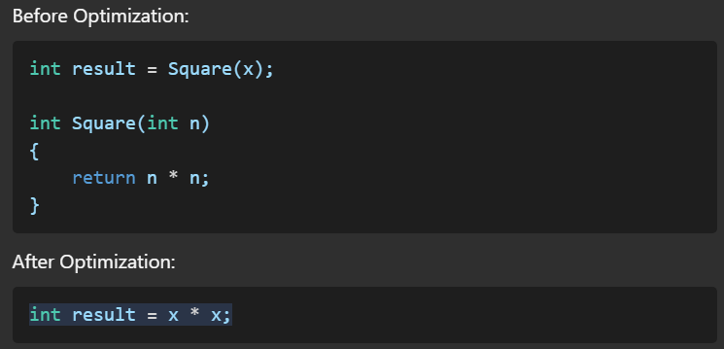

1. **Loop Unrolling**: Expanding loops to reduce iteration overhead.

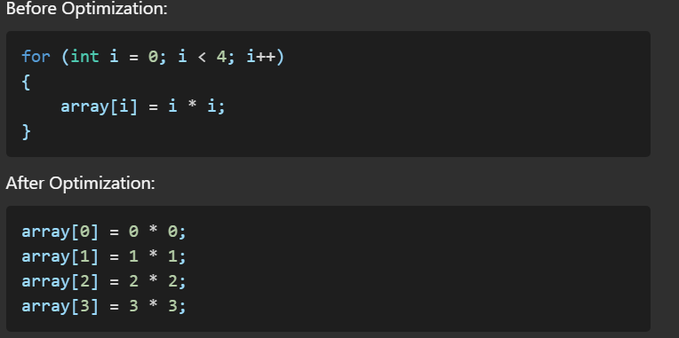

Code:  
using System.Collections.Generic;

namespace Scanner.CompilerPhases

{

public class CodeOptimizer

{

public List<string> Optimize(List<string> intermediateCode)

{

List<string> optimizedCode = new List<string>();

foreach (var line in intermediateCode)

{

if (!line.Contains("redundant"))

{

optimizedCode.Add(line);

}

}

return optimizedCode;

}

}

}

Screenshot:  
